

**DOCUMENTATION**

Building a brand-new webpage for AITU canteen

Web Technologies

ITM-2005

Astana IT University

**Overview**

**Brief information about team members:**

**Aiym Sadykova**

* Email: [204087@astanait.edu.kz](mailto:204087@astanait.edu.kz)
* Role: writing documentation, presenting part of the implementation, drawing up a conclusion on the project, helping with writing codes, help in choosing the right website design, demonstrating good skills in working with html and css.

**Amina Umbeteyeva**

* Email: [204109@astanait.edu.kz](mailto:204109@astanait.edu.kz)
* Role: creating pages, working on the registration form, using different sites like Bootstrap, Mailchimp in the implementation of the site, creating a navigation bar, connecting pages, demonstrating good skills in working with html and css.

**Alina Biksitova**

* Email: [204076@astanait.edu.kz](mailto:204076@astanait.edu.kz)
* Role: helping in writing contacts, active participation in team discussions, choosing a design for the registration form, demonstrating good skills in working with html and css.

**Akhmetova Aruzhan**

* Email: [204122@astanait.edu.kz](mailto:204122@astanait.edu.kz)
* Role: being a participant in the creation of the first page, choosing the design for the webpage, active participation in team discussions, showing a good level of possession html & css skills.

**Saya Zhumakhan**

* Email: [204146@astanait.edu.kz](mailto:204146@astanait.edu.kz)
* Role: helping with the design of the website, helping to do the first page, active participation in team discussions, demonstration of good skills in working with html and css.

**Sekenova Kamila**

* Email: [204107@astanait.edu.kz](mailto:204107@astanait.edu.kz)
* Role: helping in creating the first page, helping to choose colors, help in choosing the right website design, active participating in team discussions, showing a good level of html and css skills.
* The main goal of our project is to create a beautiful unique website for our favorite university canteen, de-illustrating our deep knowledge in html & css.
* We created a brand-new website, put all our efforts into it and used all our skills learned in web technology lessons, we chose the design of our website ourselves, we used sites such as "Mailchimp, Bootstrap", which helped us a lot, but in our work, css did not remain idle.
* We shared all the responsibilities among ourselves and engaged in their implementation, for customers in our canteen. The buyers include students of our university, teachers, professors and other employees of the university. In our website, you can reserve tables in advance if necessary, specifying the exact number of visitors, the date and leaving personal contacts. You can also view all the menus and discounts on our website.

**Project goals and team interests**

**Project goals:**

* Create a unique and modern website of our university canteen
* Reduce the number of queues using the reservation form
* Increase the growth of demand by pointing to a delicious and appetizing menu, show discounts and popular dishes in canteen

**Team interests:**

* Develop HTML & CSS skills by building an unusual website for AITU canteen
* Always be able to take part in group work, offer new ideas, be able to take responsibility and be collected and focused on your part of the work
* Learn something new that we didn't know before, strengthen knowledge in HTML tags, CSS various elements and and start building way to become a professional web creator

**Phases**

Phase 1- Unique website for our university canteen using html & css (Currently)

Phase 2- Adding more style to the site to attract the attention of the public, and adding beautiful pictures from our menu to make it more appetizing.

Phase 3- Adding more codes, so everyone can reserve a table for a special time.

Phase 4- Adding more codes, so everyone can see our valid discounts.

**Content structure**

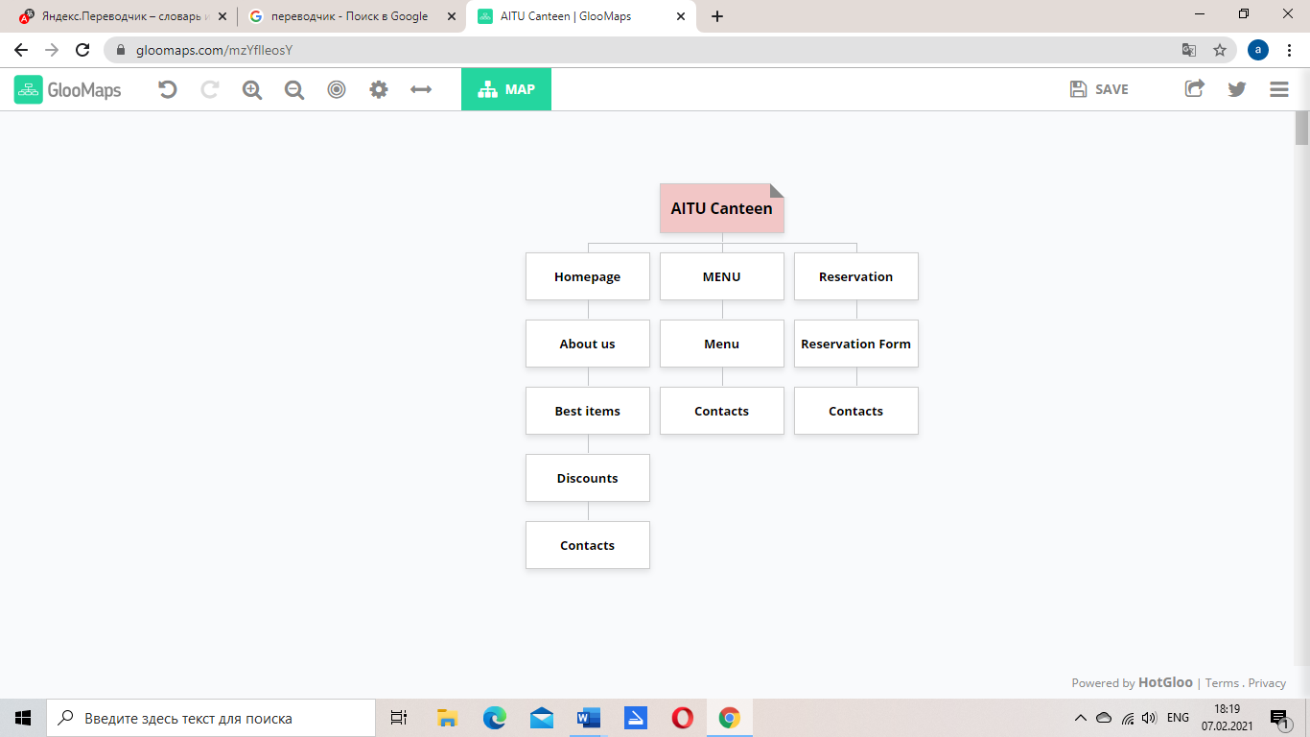

**Content types:**

* Menu
* Best items
* Discounts
* Reservation
* Contacts

**Design**

* Image files

<https://astanait.edu.kz/wp-content/uploads/2020/11/DSC01570-scaled.jpg>

<blob:https://web.telegram.org/30394be7-4320-4afb-bd9a-4e9f59290486>

<blob:https://web.telegram.org/d64e77a9-510a-4705-8600-55c316214880>

<blob:https://web.telegram.org/ceaf5aa6-8600-4050-becc-a7b28192f078>

<blob:https://web.telegram.org/10558a1c-8814-4608-9685-5218848b381c>

<blob:https://web.telegram.org/ecd1e7eb-c963-4447-a09e-0576079e0044>

<blob:https://web.telegram.org/c86f939e-7423-49c7-a043-9d13d9e166f1>

<blob:https://web.telegram.org/49611f56-6acc-4a97-8c5d-3cd3032ed1bd>

<blob:https://web.telegram.org/b8ab61df-f4f7-478d-9181-8b112b039e61>

* Reference links

<https://getbootstrap.com/docs/4.6/getting-started/introduction/>

<https://mailchimp.com/>

Colors: #FFFFF(white), #FF6600(orange), #000000(black)

Grid systems: Bootstrap grid, CSS flexbox

Hover state: Transform:scale

**Accessibility**

Accessible on all devices, for everyone. It has an appropriate, readable design and font, it has a benefit for everyone at anytime, content is well-organized, the design is clean and simple, there is no useless content, everything is done in the high-level by using the latest web technology.

**Functionality**

Reservation form:

To reserve a table in canteen, you should follow these instructions:

1. Fill in the columns with your last and first name
2. Determine the exact time of the table reserve
3. Fill out the form with accurate information and add your contacts

All fields in a reservation form are required!

Carousel with discounts:

In order to rewind the carousel, you need to click on "< > " these buttons are located on the right and left side of the image, and in the carousel itself, you can see discounts only for the present, actual moment.

Navigation Bar:

In order not to search for the necessary information for a very long time, you only need to click on the necessary icons and you can quickly read the necessary information.

**Hosting**

We decided to host our web page on GitHub, and here are the steps we took:

1. Changed the name of our html code from canteen.html to index.html

2. Uploaded all our files and photo links to our GitHub page

3. Added READ.ME files

3. Saved them all and shared our canteen web page with the general public.

**Deadlines**

Phase 1- February 5, 11:00

Phase 2- February 6, 12:00

Phase 3- February 7, 13:00

Phase 4- February 7, 15:00

**Summary**

To sum up, we can say with confidence that our site is done very carefully, unusually, restrained, formal, style and design are well compatible, we used in our site all kinds of knowledge gained in the lessons on Web technologies, as well as this practical work has helped us to strengthen our knowledge, we are very satisfied with our work done. Each member of our team showed responsibility in their part of the work, we had a lot of common discussions, we consulted on every small detail, felt the spirit of teamwork. All team interests were taken into account when working with the website, and we achieved all the goals set during the implementation of this project. Since this is our first serious experience in creating such a project as a website for our university canteen, it had some difficulties for us, but we were very satisfied with our creation and can say without a doubt that we would get good experience and practice and would rate ourselves 100%. We are very grateful to our teacher, who helped us get good knowledge in an unfamiliar deal, like coding in html & css, and thanks to him, we feel like professional web creators, which turned out to be one of the most pleasant feelings for us.